LANDIS-II v

Extension User Guide

Robert M. Scheller, North Carolina State University

Paul Schrum, North Carolina State University

Trevor Carter, University of Colorado Denver

Last Revised: March 28, 2022

# Table of Contents

1 Introduction 3

1.1 Hurricane Disturbances 3

1.2 Modelling of Landfall Wind Speed 4

1.3 Locating the Coast Line 4

1.4 Major Releases 5

1.4.1 Version 2.0 5

1.5 Minor Releases 5

1.6 Acknowledgements 5

2 Input File 6

2.1 LandisData 6

2.2 Timestep 6

2.3 InputUnitsEnglish (boolean, optional) 6

2.4 HurricaneRandomNumberSeed (integer, optional) 6

2.5 StormOccurrenceProbabilities (table) 6

2.6 Landfall Wind Speed 7

2.6.1 LowBoundLandfallWindSpeed (integer) 7

2.6.2 ModeLandfallWindSpeed (integer) 7

2.6.3 HighBoundLandfallWindSpeed (integer) 7

2.7 MeanStormIntersectionX (integer) 8

2.8 MeanStormIntersectionY (integer) 8

2.9 LandfallSigma (integer) 8

2.10 StormDirectionMu (integer) 8

2.11 StormDirectionSigma (integer) 8

2.12 ExposureMaps (table) 8

2.13 WindSpeedVulnerabilities (table) 9

2.14 MapNames 9

2.15 LogFile 9

3 Output Files 10

3.1 Max Wind Speeds Maps 10

3.2 Hurricane Events Log 10

3.2.1 Time 10

3.2.2 Year 10

3.2.3 HNumber 11

3.2.4 LandfallLatitude 11

3.2.5 LandfallMaxWindSpeed 11

3.2.6 PathHeading 11

3.2.7 StudyAreaMaxWindspeed 11

3.2.8 StudyAreaMinWindspeed 11

3.2.9 ImpactsStudyArea 11

4 Example Input File 12

# Introduction

This document describes the extension for the LANDIS-II model. For information about the model and its core concepts, see the *LANDIS‑II Conceptual Model Description.*

Base Hurricane models landscape-scale wind events (e.g., tropical cyclones) of varying strength making landfall along a coast. The model is concerned only with sustained wind. Rainfall, storm surge, tornadoes, or inland flooding are not modelled.

Mortalities are computed based on the maximum wind speed of the entire event. Though wind speeds in reality vary over the duration the event, only the maximum wind speed is considered for mortality computation. Other factors such as the effect of soil saturation may be considered to be included in the statistical representation of the Wind Speed Vulnerabilities table.

The terms "hurricane", "tropical cyclone", and "storm" are used interchangeably in this documentation.

## Hurricane Disturbances

During a hurricane time step, multiple tropical cyclone events may occur on the landscape (Figure 1). A storm which is generated by the model may hit the study area, but it may miss it. If a storm passes far enough away from the study area such that the maximum wind speed is too low, no damage is computed.

For any year, the number of wind events is randomly generated.

For each storm, initiation parameters are created: Landfall Latitude, Maximum Wind Speed at Landfall, and Storm Track Heading.

Based on these initiation parameters, a Maximum Wind Speed Field is generated on a continental grid, which is then used to compute maximum wind speed for each site of the study area.

Cohort mortality probabilities are computed based on cohort species and age compared to the maximum wind speed based on the Wind Speed Vulnerabilities table.

Figure 1. A flow chart of the order of processes.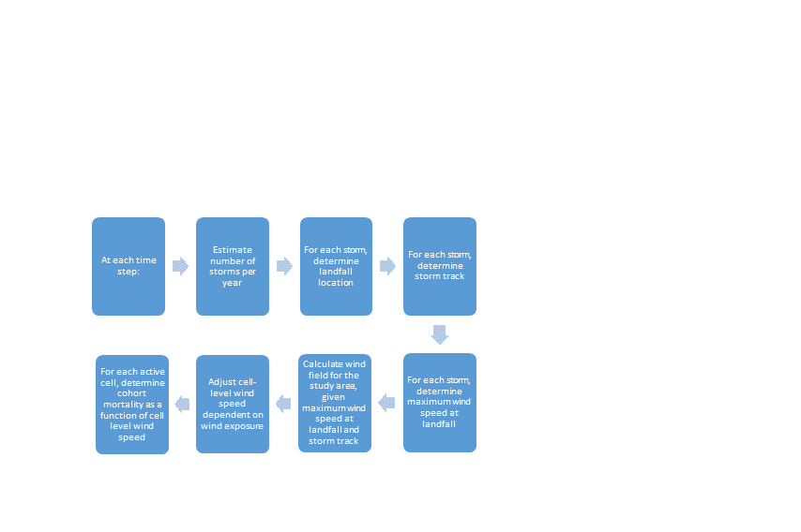

Base Hurricane does not provide a way to allow storm occurrence probabilities to change over time or to allow maximum wind speed over time.

## Locating the Coast Line

To simulate large storms with a direction and width, it is necessary to spatially identify a ‘coastline’ that storms intersect before proceeding towards and into the study area. The coastline need not literally represent a coastline; it can be any plane through which storms travel before striking the study area (Figure 2).

The meanstorm landfall location is identified with an X and Y coordinate located within the study area. A coastal ‘slope’ determines the arrangement of the coast relative to the storm center point.

Note that the overall study area must be large enough to accommodate a coastline that is large enough to produce all storms that could strike the study area. If the study area is small relative to the size of expected storms, it may be necessary to create a landscape with a small fraction of active cells. There is, however, no penalty within LANDIS-II for having one or many inactive cells. They consume neither memory or require any additional processing.

A storm can originate anywhere along the coastline (see below) and will progress in a direction determined from a normal distribution.

Figure 2. Diagram of the coastline relative to the study area, active cells, and mean landfall location and an example of a potential storm track.

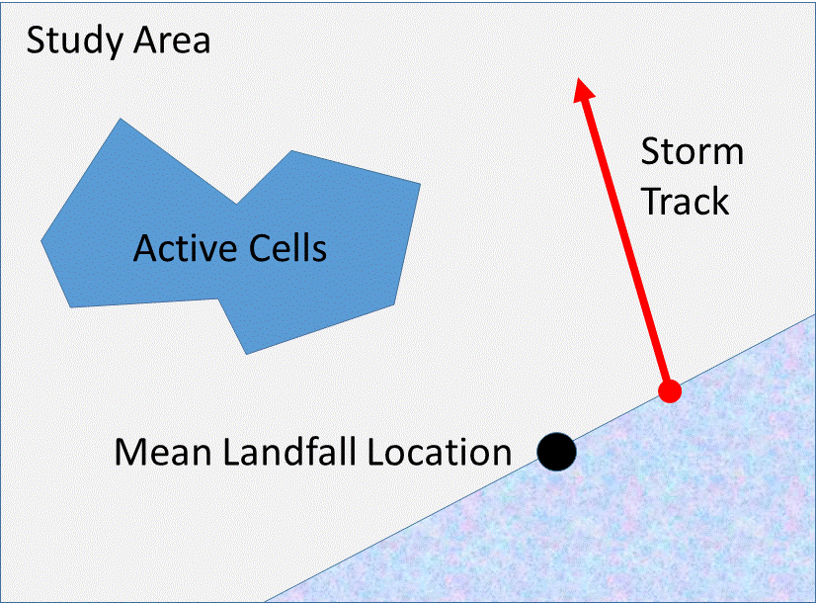

## Landfall

The location of each storm along the coastline is selected from a normal distribution assuming a mean (mu) of 0.0 (located at the Mean Landfall Intersection) and a variance (sigma).

If the bearing of the coast (the ‘coastal slope’) determines how storm locations are distributed. For example, a strictly east-west bearing will have a slope of 0. A bearing from southwest to northeast (e.g., the Atlantic coast of U.S.) has a bearing of roughly 1.0.

If the coastal slope is between 1.0 and -1.0 (a primarily east-west orientation), the randomly selected normal value (with mu = 0.0) will be applied to the east-west orientation (‘x-axis’).

If the coastal slope is greater than 1.0 or less than -1.0 (a coast that is primarily vertical, with a north-south bearing), the randomly selected normal value (with mu = 0.0) will be applied to the y-axis.

As an example, if the randomly selected normal value is -5.0, the randomly generated normal values will be applied to the north-south (‘y-axis’) because the coast has a bearing that is primarily north-south.

Note that the landfall of a storm can be outside of the study area, allowing the storm track to originate outside the study but to pass into it (Figure 3).

Figure 3. The distribution of storms along the coastline is determined by the Mean Landfall Location and a normal distribution with mu = 0.0 (centered on the mean landfall location) and a sigma (variance) determined by the user.

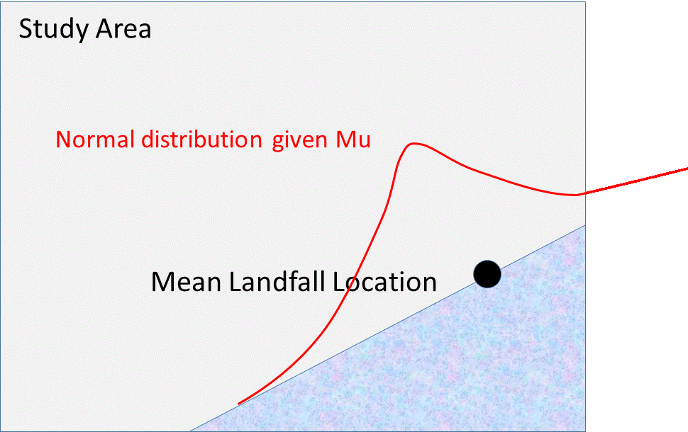

## Modelling of Landfall Wind Speed

An important controlling parameter for the model is the maximum wind speed of the storm when it makes landfall. After landfall the wind speeds are assumed to decrease.

Each storm is assigned a random landfall wind speed on a log-normal distribution. The scale of these values is determined by three parameters set in the input file: LowBoundLandfallWindSpeed, ModeLandfallWindSpeed, and HighBoundLandfallWindSpeed (Figure 4).

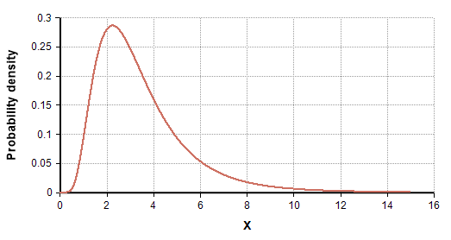

High Bound

Landfall Wind Speed

Mode Landfall Wind Speed

Low Bound

Landfall Wind Speed

Probability

Wind Speed

Figure 4. Log-normal distribution of randomly generated landfall wind speed values. Modified from <http://wiki.analytica.com/index.php?title=File%3ALogNormal(median%3D3,stddev%3D2).png>

## Major Releases

### Version 2.0

The first official release of Base Hurricane.

## Minor Releases

## Acknowledgements

Funding for the development of this LANDIS-II extension has been provided by the United States Department of Defense and the National Science Foundation.

# Input File

The input parameters for this extension are specified in one input file. This text file must comply with the general format requirements described in section 3.1 Text Input Files in the LANDIS-II Model User Guide.

## LandisData

This value of this parameter must be "Base Hurricane".

## Timestep

This parameter is the timestep of the hurricane extension. Value: integer > 0. Units: years.

## InputUnitsEnglish (boolean, optional)

InputUnitsEnglish, is optional. When present, it directs the model to interpret all wind speeds in the input file as statute miles per hour. It is a single word with no other parameters.

If the instruction is omitted, wind speeds in the input file are interpreted as kilometers per hour.

This instruction only impacts interpretation of speed in the Base Hurricane input file. Wind speeds reported in the .gis output file are in kilometers per hours in every case.

Internally all wind speeds are converted to kilometers per hour.

## HurricaneRandomNumberSeed (integer, optional)

New to LANDIS-II: The user can determine a random number seed that is separate from the Core random number seed. Doing so allows other stochastic events to vary separately from hurricanes. For example, the user might want all fires to remain the same while hurricanes varied or vice versa.

## StormOccurrenceProbabilities (table)

The number of storms which make landfall in a given year is determined with the Storm Occurrence Probabilities table. The number of storms is randomly generated at each time step. The probabilities should add up to 1.0.

Column 1: Storms per year (integer)

Column 2: The probability of that number of storm.

An example:

>> Likelihood a given year will have a given number of storms.

StormOccurrenceProbabilities

>> Storms

>> Per

>> Year Probability << Sum must = 1.0

0 0.60

1 0.33

2 0.06

3 0.01

## Landfall Wind Speed

Landfall Wind Speed is randomly determined with parameters controlled by three input file variables.

### LowBoundLandfallWindSpeed (integer)

This is the lowest wind speed that a wind storm may have.

### ModeLandfallWindSpeed (integer)

This is the most frequent wind speed that a wind storm may have.

### HighBoundLandfallWindSpeed (integer)

This is the highest wind speed that a wind storm may have.

## CoastalSlope (integer)

The coastal ‘slope’ determines the arrangement of the coastline; the coastline runs through the mean landfall point.

## MeanLandfallIntersectionX (integer)

The Mean Landfall Intersection is the average landfall location (point) for storms along the coast.

It is measured as the distance of the mean storm intersection from the western edge of the study area, in kilometers.

## MeanLandfallIntersectionY (integer)

The distance of the mean storm intersection from the southern edge of the study area, in kilometers.

## LandfallSigma (integer)

The location of each storm along the coastline is selected from a normal distribution assuming a mean (mu) of 0.0 (located at the Mean Landfall Intersection) and a variance (sigma).

## StormDirectionMu (integer)

The mean storm direction in degrees. A normal distribution is used to determine the actual direction, in combination with the sigma value, below.

## StormDirectionSigma (integer)

The variance of the storm direction.

## ExposureMaps (table)

New for version 2: The land surface can vary by exposure, dependent on wind direction. For example, a storm out of due south may affect north facing slopes to a lesser degree. Therefore a table is now required indicating a map and an associated degree. For each storm generated, the closest degree map will be used to modify wind speeds.

The map itself should contain nine (9) classes, each associated with a proportion reduction in wind speed (0.0 – 1.0). See exposure classes table??

The table has two columns (there is no header):

Column 1: Degree (integer)

Column 2: Map Name (file name)

## ExposureClasses (Table)

The Exposure Classes table indicates the reduction in cell-level wind speed by each of the nine exposure classes.

The table has two columns (there is no header):

Column 1: Exposure Class (integer)

Column 2: Fractional reduction (double: 0.0 – 1.0)

## WindSpeedVulnerabilities (table)

High winds kill cohorts at different rates according to species and age. To represent this, the mortality probabilities are entered into the Wind Speed Vulnerabilities table, a segment of which is depicted here.

WindSpeedVulnerabilities

>> Species MaxAge Mortality Probabilities

LobPine 30 60:0.05 75:0.18 110:0.75 140:1.0

LobPine 60 60:0.1 75:0.23 110:0.75 140:1.0

LobPine 999 60:0.1 75:0.29 110:0.75 140:1.0

Column 1: The name of the species. This must be consistent with species names in the species txt file.

Column 2: The maximum cohort age in years for the given table row. The final row for any species should have a very high age (such as 999) to represent the oldest cohorts.

Column 3: Contains the colon-delimited pairs of values where the first number is the wind speed and second number is the probability of mortality. For example, a value of "60:0.05" means that site wind speeds of less than 60 kph (or mph if set to English) result in 5% cohort mortality.

## MapNames

This file parameter is the template for the names of the wind severity output maps. The parameter value must include the variable “timestep” to ensure that the maps have unique names (see section 3.1.8.1 Variables in the LANDIS-II Model User Guide). The user must indicate the file extension. The user must also include sub-directory name(s) as needed.

## LogFile

The file parameter is the name of the extension’s event log file.

# Output Files

The wind extension generates two types of output files: a) a map of maximum wind speed for each impacting storm, and b) a log of hurricane events for the entire scenario.

## Max Wind Speeds Maps

The max wind speeds map shows the maximum wind speed for each cell of the study area for a given storm, but only if that storm has impact on the study area.

## Hurricane Events Log

The event log is a comma-separated-value text file that contains information about every storm over the course of the scenario. Every storm is logged whether it impacts the study area or not.

### Time

The time step of the given storm.

### Year

The year number of the given storm.

### HNumber

The hurricane number of the given storm in the current year.

### LandfallLatitude

The latitude where the given storm makes landfall (crosses the coast line).

### LandfallMaxWindSpeed

The wind speed of the given storm at the point of landfall.

### PathHeading

The direction (in Azimuth form) that the given storm takes as it progresses inland.

### StudyAreaMaxWindspeed

The highest maximum wind speed of any active site in the study area.

### StudyAreaMinWindspeed

The lowest maximum wind speed of any active site in the study area.

### ImpactsStudyArea

"Yes" if the given storm has a chance of causing any mortalities in the study area. "No" if it does not.

# Example Input File